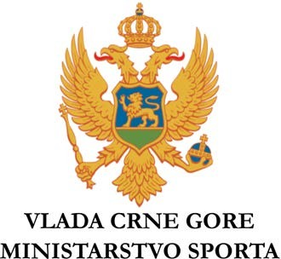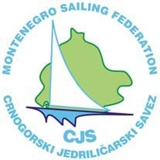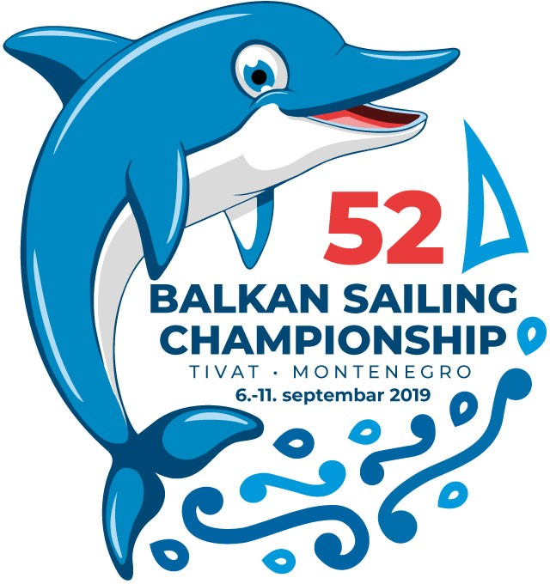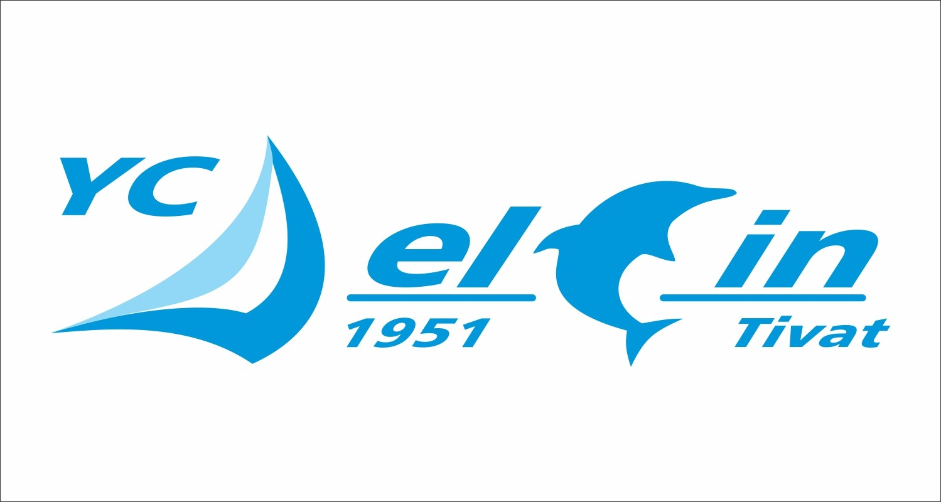

52nd OLYMPIC CLASSES AND OPTIMIST BALKAN SAILING CHAMPIONSHIP
the Municipality Tivat, Boka Bay, Montenegro from 06 to 11 September 2019.
ENTRY FORM

CLASS ...................................................

SAIL NUMBER ....................................

COUNTRY ............................................

CATEGORY M W J

HELMSMAN NAME & FIRST NAME ..........................................................................

HELMSMAN BIRTHDAY ..............................................................................................

CREW’S NAME & FIRST NAME (if any) ..................................................................... CREW’S BIRTHDAY ......................................................................................................
Entry Declaration – By signing this entry form I/We confirm that the sailors or coach agree to be bound by The Racing Rules of Sailing 2017 - 2020 and by all other rules that govern this event. I/We confirm that the sailors or coach as well as the boats here entered meet all the requirements stipulated in the Notice of Race. We declare our boat has valid third party liability insurance to a minimum cover amount as required by the Notice of Race.

By signing this Entry Form, we declare that we are sailing at our own risk and responsibility. The Organizing Authority and any other person or entity, involved in the organization of the event will not accept any liability for any loss, damage, injury or death which may occur to person or property, both ashore and afloat, as a consequence of participation in the event.

HELMSMAN SIGNATURE.............................................................................................

CREW’S SIGNATURE (if any) ........................................................................................ DATE ..................................................................................................................................
We certify that crew are member(s) of our National Authority and have been designated to compete in this Balkan Championship.

National Association’s stamp or Team Leader’s signature

